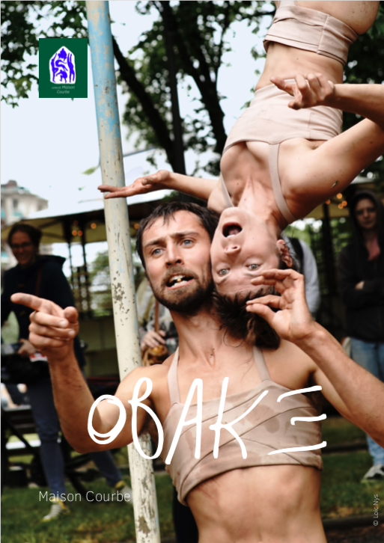**KIT COMMUNICATION**

**Company name :** Collectif Maison Courbe

**Show name :** OBAKE

**Creacion :** 2022

**Duration :** 50 min to 1h

**Type :** Circus & dance for public areas, walkabout

**Cast**

**Created and performed by** Hélène Leveau & Léo Manipoud

**Cyber onlooker :** Nicolas Chapoulier

**Onlookers :** Yuko Kobayashi, Jérémy Damian, Juliette Steimer

**Research into clay painting :** Mathilde Leveau

**Costume design :** Clémence Roger

**Technician :** Thibaud Rocaboy

**In charge of production :** Michel Rodrigue

**In charge of tour :** Guillaume Cornu - *L’Envoleur*

**Administrator :** *Veda Sphère*

**Synopsis**

Obaké, that’s two shape-shifting creatures crossing through the human world.

Inseparable duo, Parpaing and Moellon, (Parpen andAshlar) have been called for a task the sense of which we cannot grasp. They pass through space with their malleable bodies and skin-deep sensitivity. We see them outlining our architecture, stalking the invisible and using all they can to further their quest.

In a universe where magic and sacred flirt with stupidity,we take a new look at our public areas and the beings around us.

**A few words about the company**

Maison courbe is a collective structure founded by Inbal Ben Haim, Léo Manipoud, NinaHarper, Domitille Martin et Kamma Rosenbeck with the aim of producing various artistic projects.

The projects are pluridisciplinary, between live performances, art exhibitions and in situ shows, the common finality being the research of dialogue between bodies, matter and space.

**Company web site :** https://www.lenvoleur.com/collectifmaisoncourbe

**Teaser video :** <https://youtu.be/gMgsuby6mt0>

**Obligatory mentions :**

**Production** collectif Maison Courbe

**Scope Production during creation** Bonlieu Scène Nationale - Annecy

**With the support of** Bonlieu scène nationale - Annecy / CCN2 de Grenoble / Atelier 231, CNAREP Sotteville-Lès-Rouen / Le Citron Jaune , CNAREP Port St-Louis du Rhône / Espace Périphérique , Ville de Paris - La Villette / Le Plongeoir - Cité du Cirque, PRAC du Mans / In Situ - European Platform for artistic creation in Public Space

**With the welcome of** Latitude 50 - Pôle des arts du cirque et de la rue / ARMODO, *the soft arts network*

**Subsidies** Drac Auvergne - Rhône-Alpes

**Social Network :**

<https://www.facebook.com/collectif.maison.courbe>

**Photo credits :** ©Loïc Nys // ©Melaine Freund // ©Anne-Laure Chemin

**Attached file :**

Pictures HD, Kit Press, Poster